|  |
| --- |
| detail of persons hands with scissors, markers, workingSystem Design |

|  |  |  |
| --- | --- | --- |
| Fanlinc |  |  |
| Aamir Haroon Abel Debalkew Prashyen Kanagarajah Carl Alvares  Rahul Ramani Ruidan Ji Tahasun Tarannum |  |  |

TABLE OF CONTENTS

System Architecture 3

Architecture Diagram 3

System Architecture Description 4

Handling Exceptions 5

System Interaction with Environment 6

CRC Cards for Back-End Java Classes 7

Component Breakdown for Front-End React Components 16

# System Architecture

## Architecture Diagram

## System Architecture Description

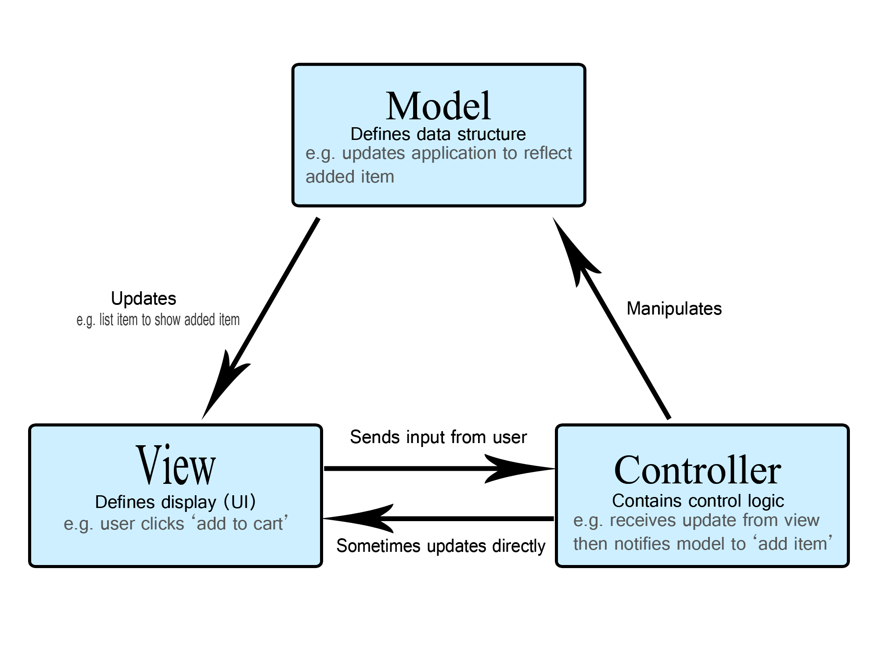The architecture of the System is designed based on the Model-View-Controller pattern. More information about the MVC pattern can be found here: https://www.geeksforgeeks.org/mvc-design-pattern/, where the blue boxes indicate the models, the orange boxes indicate the controller and the green boxes indicate the view. The Models are manipulated by the controllers, the controller receives information from the view to determine which models must be manipulated. Once the models are manipulated, the view is updated from the model. A diagram of the MVC pattern is displayed below.

Within the Model aspect, there are two types of objects, a node, and a relationship. Fandom, User and Post are all nodes whereas JOINED is a relationship. In this specific design, the relationships play the role of interconnecting the nodes. The information stored by each object is defined in the architecture diagram on page 3.

This design consists of three controllers, the AccountController, FeedController, and FandomController. The AccountController is responsible for profile or account related API calls such as creating an account or editing a profile. This controller interacts/manipulates the user model to acquire/update information about the user, as well as interacts or manipulates the JOINED model, to keep track of fandoms joined by the user. The FeedController is responsible for generating the feed with posts, it interacts and/or manipulates the post model to get or edit information about posts. The FandomController is responsible for acquiring information about the fandoms, which interacts and/or manipulates the fandom model to get information about the fandoms.

The design focuses on four main views, the LoginPage, the SignUpPage, the ProfilePage, and the FeedPage. The LoginPage deals with scenarios in which the user attempts to click the sign-up button or inputs user info and clicks the login button. When the user clicks the signup button, the user gets redirected to the signup page. However, if the user attempts to log in, the AccountController is sent the input, which interacts with the user model and returns the response back to the view on whether the login was successful or not. The SignUpPage deals with the user attempting the create a new account, this scenario also interacts the AccountController, manipulating the user, and JOINED model and returning the response back to the view. The ProfilePage is for the user to either view or edit the profile, hence it interacts with the AccountController which manipulates or interacts with the user and JOINED models. The FeedPage is responsible for displaying posts, allowing the user to create posts. Thus, the FeedPage interacts with the FeedController, which manipulates the post and interacts with the post model when displaying posts.

## Handling Exceptions

There are numerous Exceptions that must be handled across the various pages. These Exceptions will be displayed in the UI with a dialog message describing the error. The status code will be based on the type of exception which can found at this link: <https://developer.mozilla.org/en-US/docs/Web/HTTP/Status> .The LoginPage handles error caused by the username and/or password being incorrect using a UserNotFoundException which returns a 404 status code. If the user attempts to log in with the username, or password or both fields missing, a 400 stats code is returned by Spring. The SignUpPage handles errors caused by an account with the same username already existing when attempting the create an account with a UsernameNotUniqueException, which return a 409 Status code. Missing field errors when signing up are handled with a 400 status code by Spring. For the ProfilePage, when attempting to edit the profile the same exceptions are thrown as the SignUpPage, for the username not being unique and for missing fields. The FeedPage will throw an exception with 400 status code missing fields when attempting to post. For the case where the database can’t be reached, a 500 status code is returned, and the UI will display a Pop up with the message “Please restart the application”.

## System Interaction with Environment

Prior to running the application, certain assumptions must be made. A Neo4j database must be running on http://localhost:8080 and bolt://localhost:7687 with database username set to “Neo4j” and password set to “secret”.

## CRC Cards for Back-End Java Classes

Class name: UserBuilder

Parent class (if any):

Subclasses (if any):

Responsibilities:

* Creates a user

Collaborators:

* User

Class name: FandomBuilder

Parent class (if any):

Subclasses (if any):

Responsibilities:

* Creates a Fandom

Collaborators:

* Fandom

Class name: PostBuilder

Parent class (if any):

Subclasses (if any):

Responsibilities:

* Creates a Post

Collaborators:

* Post

Class name: AccountController

Parent class (if any):

Subclasses (if any):

Responsibilities:

* Profile or account related API calls such as creating an account or editing a profile
* Interacts/manipulates the user model to acquire/update information about the user
* Interacts or manipulates the JOINED model, to keep track of fandoms joined by the user

Collaborators:

* AccountService

Class name: FeedController

Parent class (if any):

Subclasses (if any):

Responsibilities:

* Generates the feed with posts
* Interacts and/or manipulates the post model to get or edit information about posts

Collaborators:

* Feed

Class name: FandomController

Parent class (if any):

Subclasses (if any):

Responsibilities:

* Responsible for acquiring information about the fandoms,
* Interacts and/or manipulates the fandom model to get information about the fandoms.

Collaborators:

* Fandom
* FandomService

Class name: UsernameNotUniqueException

Parent class (if any): RuntimeException

Subclasses (if any):

Responsibilities:

* Exception error for throwing when a Username is not unique

Collaborators:

Class name: UserNotFoundException

Parent class (if any): RuntimeException

Subclasses (if any):

Responsibilities:

* Exception error that is thrown when a User is not found

Collaborators:

Class name: User

Parent class (if any):

Subclasses (if any):

Responsibilities:

* Holds all the variables and methods of a user class

Collaborators:

Class name: Fandom

Parent class (if any):

Subclasses (if any):

Responsibilities:

* Holds all the variables and methods of a Fandom class

Collaborators:

Class name: Post

Parent class (if any):

Subclasses (if any):

Responsibilities:

* Holds all the variables and methods of a Post class

Collaborators:

Class name: UserRespository

Parent class (if any): Neo4jRepository

Subclasses (if any):

Responsibilities:

* Interface with method to find a user given a username

Collaborators:

* UserRespository

Class name: AddUserRequest

Parent class (if any):

Subclasses (if any):

Responsibilities:

* Request to add a user

Collaborators:

Class name: ValidateUserRequest

Parent class (if any):

Subclasses (if any):

Responsibilities:

* Request to validate User

Collaborators:

Class name: AddUserResponse

Parent class (if any):

Subclasses (if any):

Responsibilities:

* Response when user added

Collaborators:

Class name: ValidateUserResponse

Parent class (if any):

Subclasses (if any):

Responsibilities:

* Response when user validated

Collaborators:

Class name: AccountService

Parent class (if any):

Subclasses (if any):

Responsibilities:

* Username and password validation
* Adds Users in the database

Collaborators:

* UserRespository

Class name: PostController

Parent class (if any):

Subclasses (if any):

Responsibilities:

* Handles endpoints related to the Post model (creating, updating, retrieving)

Collaborators:

* PostService

Class name: PostService

Parent class (if any):

Subclasses (if any):

Responsibilities:

* Retrieves and updates Post models using the PostRepository, then manipulates them and formats them to send through the endpoints in PostController
* Performs error checking on parameters sent through requests

Collaborators:

* PostController
* PostRepository
* UserRepository
* FandomRepository

Class name: PostRepository

Parent class (if any): Neo4jRepository

Subclasses (if any):

Responsibilities:

* Contacts database to retrieve and update Post objects

Collaborators:

* Post

Class name: JoinedRepository

Parent class (if any): Neo4jRepository

Subclasses (if any):

Responsibilities:

* Contacts database to retrieve and update Joined objects

Collaborators:

* Joined

Class name: JoinedBuilder

Parent class (if any):

Subclasses (if any):

Responsibilities:

* Creates a Joined object

Collaborators:

* Joined

Class name: UserDetailsResponseBuilder

Parent class (if any):

Subclasses (if any):

Responsibilities:

* Creates a UserDetailsResponse object

Collaborators:

* UserDetailsResponse

Class name: AddFandomRequest

Parent class (if any):

Subclasses (if any):

Responsibilities:

* Request to add a fandom

Collaborators:

Class name: AddJoinedFandomRequest

Parent class (if any):

Subclasses (if any):

Responsibilities:

* Request to join a user to a fandom

Collaborators:

Class name: AddPostRequest

Parent class (if any):

Subclasses (if any):

Responsibilities:

* Request to add a post

Collaborators:

Class name: UserDetailsRequest

Parent class (if any):

Subclasses (if any):

Responsibilities:

* Request to get details of a user

Collaborators:

Class name: UserFandomsRequest

Parent class (if any):

Subclasses (if any):

Responsibilities:

* Request to get the fandoms a user has joined

Collaborators:

Class name: AddFandomResponse

Parent class (if any):

Subclasses (if any):

Responsibilities:

* Response from addFandom API

Collaborators:

Class name: AddJoinedFandomResponse

Parent class (if any):

Subclasses (if any):

Responsibilities:

* Response from addJoinedFandom API

Collaborators:

Class name: AddPostResponse

Parent class (if any):

Subclasses (if any):

Responsibilities:

* Response from addPost API

Collaborators:

Class name: FilterPostsResponse

Parent class (if any):

Subclasses (if any):

Responsibilities:

* Response from filteredPosts API

Collaborators:

Class name: UserDetailsResponse

Parent class (if any):

Subclasses (if any):

Responsibilities:

* Response from userDetails API

Collaborators:

Class name: UserFandomsResponse

Parent class (if any):

Subclasses (if any):

Responsibilities:

* Response from userFandoms API

Collaborators:

Class name: UserNotInFandomException  
Parent class (if any): RuntimeException  
Subclasses (if any):  
Responsibilities:

* Exception error for throwing when a User tries to post in a Fandom that they are not a part of.

Collaborators:

Class name: FandomAlreadyExistsException  
Parent class (if any): RuntimeException  
Subclasses (if any):  
Responsibilities:

* Exception error for throwing when a users tries to create a fandom that already exists

Collaborators:

Class name: UserAlreadyJoinedFandomException  
Parent class (if any): RuntimeException  
Subclasses (if any):  
Responsibilities:

* Exception error for throwing when a User attempts to join a Fandom that they have already joined

Collaborators:

Class name: FandomNotFoundException  
Parent class (if any): RuntimeException  
Subclasses (if any):  
Responsibilities:

* Exception error for throwing when a Fandom is not found

Collaborators:

Class name: InvalidLevelException  
Parent class (if any): RuntimeException  
Subclasses (if any):  
Responsibilities:

* Exception error for throwing when level is not one of {“1”, “2”, “3”, “4”}

Collaborators:

Class name: InvalidTypeException  
Parent class (if any): RuntimeException  
Subclasses (if any):  
Responsibilities:

* Exception error for throwing when type is not one of {“General”, “Vendor/Artist”, “Cosplayer”}

Collaborators:

## Component Breakdown for Front-End React Components

Component name: Root

Responsibilities:

* Wraps the App component with CookiesProvider to provide cookie manipulation
* Renders App in the DOM

Collaborators:

* App
* CookiesProvider (from react-cookie library)

Component name: App

Responsibilities:

* Stores the cookies object and passes it to components where it is required
* Handles routing, directing to appropriate components

Collaborators:

* Login
* Register
* Home

Component name: Login

Responsibilities:

* Takes username and password from user, and validates it using an API call to server
* Sets loggedInUser cookie if user is authenticated

Collaborators:

* Home
* Register

Component name: Register

Responsibilities:

* Takes account details from user, and attempts to create an account with those details using an API call to server
* Sets loggedInUser cookie if user account is successfully created

Collaborators:

* Home
* Login

Component name: Home

Responsibilities:

* Contains the main components of the logged in view (Header and sidebars)
* Displays appropriate sidebar (FeedSidebar or ProfileSidebar) based on route

Collaborators:

* Login
* Header
* FeedSidebar
* ProfileSidebar

Component name: Header

Responsibilities:

* Displays logo and username of user currently logged in
* Contains a logout button which sets the loggedInUser cookie to null

Collaborators:

* Home

Component name: FeedSidebar

Responsibilities:

* Displays list of fandoms, populated with an API call to server
* Displays Feed component and passes in the fandom name based on what user clicks

Collaborators:

* Home
* Feed

Component name: Feed

Responsibilities:

* Displays list of posts from the passed in fandom name or passed in username using an API call to server
* If fandom name was passed, displays PostModal component and passes in the fandom name to this component

Collaborators:

* FeedSidebar
* PostModal
* ProfileSidebar

Component name: PostModal

Responsibilities:

* Displays a modal that can be clicked to bring up a “create post” dialog
* Allows user to enter details for a post and submit it to the passed in fandom name using an API call to server

Collaborators:

* Feed

Component name: ProfileSidebar

Responsibilities:

* Displays information about logged in user, populated with an API call to server
* Displays Feed component and passes in the username of the currently logged in user

Collaborators:

* Home
* Feed